


Specification


Project Acronym: | PEPPOL
Grant Agreement number: | 224974
Project Title: | Pan-European Public Procurement Online
Pre Award eProcurement
Conformance and Test

Conformance and Test
Specification

Version: 4.0.0
Status: In use

Editors:
Philip Helger, PEPPOL.AT/BRZ
Susanne Kamptner, PEPPOL.AT/BRZ
Giancarlo De Stefano, Consip

Project co-funded by the European Commission within the ICT Policy Support Programme
Dissemination Level
P | Public | X
C | Confidential, only for members of the consortium and the Commission Services
Revision History

Revision | Date | Editor | Org | Description
1.0 | 30.10.2010 | Susanne Kamptner | BRZ | First version for eInvoicing and eOrdering (pending EC approval)
1.1 | 25.03.2011 | Bergthor Skulason | NITA | Align for all post award documents  Focus on providing support for external implementers
1.2 | 30.03.2011 | Susanne Kamptner | BRZ | Review of 1.1 changes,
1.3 | 11.04.2011 | Bergthor Skulason | NITA | Update definition of terms
1.4 | 29.04.2011 | Susanne Kamptner | BRZ | Overall restructuring and integration of existing Testing guideline v1.0 for Transport Infrastructure
1.5 | 06.06.2011 | Klaus V. Pedersen  Bergthor Skulason | DIFI  NITA | Review of text
1.9 | 08.06.2011 | Susanne Kamptner  Philip Helger | BRZ | Review and restructuring chapter 6.2; consolidation of review-comments
2.0 | 08.06.2011 | Susanne Kamptner  Philip Helger | BRZ | Joint guideline for all PEPPOL subject areas, joining earlier guidelines of post award and infrastructure.
2.7 | 07.11.2011 | Alexander Forst-Rakoczy | 42virtual | Spilt up guidelines according to subject area.  Draft, including comments
2.8 | 14.11.2011 | Alexander Forst-Rakoczy | 42virtual | Incorporated comments
2.9 | 20.12.2011 | Alexander Forst-Rakoczy | 42virtual | Incorporated results from the F2F meeting in Vienna
3.00 | 11.1.2012 | Alexander Forst-Rakoczy | 42virtual | Corrected minor errors, formats and layout issues
3.01 | 19.4.2012 | Alexander Forst-Rakoczy | 42virtual | Minor update.
4.0 | 30.6.2012 | Giancarlo De Stefano | Consip | Adapted content to pre award needs

Statement of originality

This deliverable contains original unpublished work except where clearly indicated otherwise. Acknowledgement of previously published material and of the work of others has been made through appropriate citation, quotation or both.
Statement of copyright
This deliverable is released under the terms of the Creative Commons Licence accessed through the following link: http://creativecommons.org/licenses/by/3.0/.

In short, it is free to
Share — to copy, distribute and transmit the work
Remix — to adapt the work
Under the following conditions
Attribution — You must attribute the work in the manner specified by the author or licensor (but not in any way that suggests that they endorse you or your use of the work).
Contributors

Organisations
DIFI (Direktoratet for forvaltning og IKT) , Norway, www.difi.no
NITA (IT- og Telestyrelsen) , Denmark, www.itst.dk
PEPPOL.AT/BRZ, Bundesrechenzentrum, Austria, http://www.brz.gv.at/
PEPPOL.AT/BBG, Bundesbeschaffung, Austria, http://www.bbg.gv.at
Consip, Italy, http://consip.it

Persons
Jens Jakob Andersen, NITA
Kambiz Aria, PEPPOL.AT/BRZ
Georg Birgisson, Eykur
Oriol Bausà Peris, Invinet
Philip Helger, PEPPOL.AT/BRZ
Susanne Kamptner, PEPPOL.AT/BRZ (editor)
Andrea Leutgeb, PEPPOL.AT/BBG
Bergtor Skulason, NITA
Klaus Vilstrup Pedersen, DIFI
Arianna Brutti, Intercenter (ENEA)
Giancarlo De Stefano (Consip)

Table of Contents

1 Introduction 5
1.1 Objective and Scope 5
1.2 Audience 5
1.3 The PEPPOL BIS – short overview 5
1.4 PEPPOL Implementation support 5
1.5 References 6
2 Overall PEPPOL QA and Testing landscape 6
2.1 PEPPOL Interoperability and clarification of terms 6
3 Test process and schedule 8
3.1 Test Roles 8
3.2 Overall Testing Process 8
4 Functional Testing Scope 10
4.1 Standalone Document Validation 10
4.2 SUT-Interactive Conformance Testing 10
4.3 Validation 10
5 Test environment and organisational test preparation 12
5.1 Test planning and controlling 12
5.2 Test preparation 12
5.3 Test case design 12
5.4 Test execution and documentation 13
5.5 Defect Management 14
5.6 Reporting 15
6 Test Tools 15
6.1 Test Management Tool 16
6.2 Validation Tool 19
Appendix – Abbreviations 27

Introduction

Objective and Scope
The scope of this document is to provide a guideline to PEPPOL conformance and interoperability as well as the PEPPOL agreed standards on quality assurance for testing of document contents in pre award processes involving the use of eCatalogues. The target group for this document is implementers of PEPPOL specifications – they should use it as a guideline for testing for BIS conformance as basis for claiming PEPPOL conformance

Audience

The audience for this document is organizations wishing to be PEPPOL enabled for exchanging Catalogues, in the pre-award phase, i.e. the following PEPPOL Stakeholders:

- PEPPOL Community Governance
- Contracting Authorities
- Economic Operators
- ICT Providers
- Service Providers

More specific it is the following roles:

- Business Experts
- ICT Architects
- ICT Developers
- ICT Governing participants

The PEPPOL BIS – short overview
The PEPPOL BIS (Business Interoperability Specification) provides a set of specifications for implementing PEPPOL business documents. The specifications enable any company to issue electronic documents that fulfil legal and business processing requirement within the European Union and the EEA. It supports a subset of information that is used by most industries and enables users to issue documents (invoices, orders, etc...) that are valid for cross border trade within the European Union and the EEA.
The BIS specifications are based on set of requirements to provide support for “common business processes” and legal requirements. The BIS identifies a small set of information elements and business rules as a basis for supporting these requirements. A selection of business rules places restrictions on the data elements to fulfil the requirements and clarify choices otherwise left open to implementers.

PEPPOL Implementation support
PEPPOL has set up the PEPPOL Enterprise Interoperability Architecture (EIA) – that presents the PEPPOL artefacts in a repository. The EIA repository is a three dimensional matrix for organizing results of the project. The PEPPOL EIA is a 3 dimensional cube you can navigate by clicking a one of the blue cell in the frame.For more information about the PEPPOL EIA, see [PEPPOL_EIA].
The latest version of this document can be found in: Pre Award eProcurement / Conformance and test / Models.

References
[PEPPOL] http://www.peppol.eu/
[PEPPOL_EIA] http://www.peppol.eu/peppol_components/peppol-eia/eia
[PEPPOL_PostAward] http://www.peppol.eu/PostAward
[PEPPOL_Transp] http://www.peppol.eu/Transp

[PHLOC] PEPPOL Test Management and Development
http://peppol.phloc.com/
http://peppol.phloc.com/config

[GITB] Global eBusiness Interoperability Test Bed methodologies
http://www.cen.eu/cen/Sectors/Sectors/ISSS/Workshops/Pages/Testbed.aspx
ftp://ftp.cen.eu/CEN/Sectors/List/ICT/GITB2_draft_CWA.pdf

[CEN_BII] www.cen.eu/cwa/bii/specs
[CENBIITG] Test Guidelines ver 1.0
http://www.cen.eu/cwa/bii/specs/Pilot/IndexWG4.html
http://www.cen.eu/cwa/bii/specs/Pilot/Annex%201/BII%20WG4%20WG4%205%20Test%20Guidelines%20ver%201.0.doc

[BISSWG] ICT PreAward BIS SoftwareGuidelines

[EIF] European Interoperability Framework 2.0, found at:
http://ec.europa.eu/isa/library/index_en.htm
http://ec.europa.eu/isa/documents/isa_annex_ii_eif_en.pdf

[CTPATF] Conformance and Testing, Pre Award Test Framework

Overall PEPPOL QA and Testing landscape
  - PEPPOL Interoperability and clarification of terms
The goal of PEPPOL interoperability is to electronically enable parties to exchange a set of information to be used within a minimal but well defined set of procurement processes without previous bi lateral setup of data, content rules and process specifications. Electronic documents that are conformant to PEPPOL BIS specifications can be exchanged widely within Europe in open procurement communities (if wished, using the PEPPOL Transport Infrastructure that ensures transparent transport between existing eProcurement solutions). An issuer of a document can with high degree of certainty expect the document to pass validation by the receiver. The conformance specifications also serve as a basis for bi lateral specification of additional information to be exchanged between trading parties.
An important cornerstone for the Test Guidelines is the European Interoperability Framework [EIF], an initiative run by IDABC (Interoperable Delivery of European eGovernment Services to public Administrations, Business and Citizens).

PEPPOL has aligned its testing scope and terminology with the GITB Testing Framework [GITB]. PEPPOL strongly recommends a test bed which allows automatic testing.

PEPPOL conformance
PEPPOL compliance means that a solution or implementation of PEPPOL process is conformant to all legal and business requirements, process, semantic and technical solutions defined by PEPPOL or committed and approved by PEPPOL.

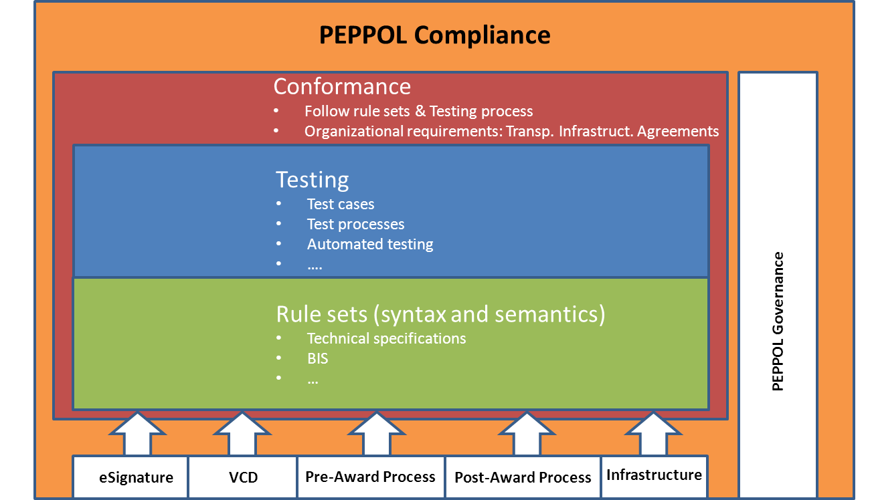
Figure 1: Overview of compliance, conformance and testing.

PEPPOL conformance testing is defined as a process for implementers to claim conformance to a set of legal and technical specifications defined by PEPPOL. PEPPOL conformance is therefore based on self evaluation. Figure 1 explains the relationship between compliance and conformance and demonstrates the role of testing in conformance.

Role of Testing and validation
Testing and validation provide the processes and tools for participant to claim conformance. PEPPOL testing therefore defines a set of activities containing test processes and test cases to ensure the functional and non-functional requirements of the system work together as defined by the different PEPPOL artefact interoperability requirements (eSignature validation,, Pre Award eProcurement, Post Award eProcurement and Transport Infrastructure).

The rule sets are provided by PEPPOL subject communities and are the relevant specifications that must be tested for claiming conformance.

How is conformance achieved
Pilot participant must claim conformance to PEPPOL specifications. This is based on a self evaluation process supported by guidelines, test documents and compliance criterias.

Conformance criteria for PEPPOL Communities
Every PEPPOL Community defines a set of specifications and requirements that must be fulfilled as part of definition of conformance for that Community. These are the rule sets (requirements) that must be met by all that claim conformance in the Community.

For the PEPPOL Pre Award, conformance is defined as:
- The Solution must be able to receive/upload and/or send/submit documents according to one role in a PEPPOL BIS.
- The Solution can create document instances which must conform to the document specifications and business rules that apply to the content.
- Conformance is defined in terms of buyer and seller (systems). Service providers CAN take on a role on their behalf, but they do NOT by themselves play any role in PreAward conformance.
- The solution provider must execute the relevant test cases according to the Solution’s role in a PEPPOL BIS.

In terms of electronic documents an XML instance is conformant to a PEPPOL BIS Document when:
- It is a valid instance in terms of its syntactical structure.
- It has no other elements than the ones considered valid according to the declared Customization Identifier.
- It fulfils the business rules defined by the PEPPOL BIS.

Test process and schedule

Test Roles
When executing tests different roles must be assigned. One person can often easily be assigned to several roles; the purpose of describing several roles is to simplify the division of responsibility in larger test assignments.

The names of the roles come from [GITB]. Corresponding roles from [CTPATF] are in parentheses.

Role | Responsibilities | Assignment
Test Designer  (Test manager, Test data manager) | Creates test suites (test cases, document assertion tests, configuration artefacts)  Understands eBusiness domain  Understands testing conditions and constraints  Familiar with the testing framework methodology and best practices | Mandatory
Test Participant  (Tester) | Owns or operates the SUT (System Under Test)  Responsible for eBusiness implementation  Must have business domain expertise | Mandatory
Test Manager  (Test manager) | Responsible for executing Test Suites  Coordinates with Test Participants  Assists Test Participants in using the Test Bed  Familiar with the Test Suite Logic and related eBusiness domain | Recommended
Test Bed Provider  (Test environment manager) | Operates the Test Bed  Responsible for keeping the Test Bed functionally operational | Recommended

Overall Testing Process
The Test Process follows the sub processes that are outlined in [CTPATF]: Mobilise, Prepare, Execute, and Summarize. Figure 2 gives a more detailed overview.
Figure 2: QA and testing process

- Test planning and controlling (Mobilize)
  - Requirements analysis: Determine what aspects of a design are testable and with which parameters those tests work.
  - Create the test concept
  - Define the test environment and infrastructure, e.g. Hardware, Software
  - Define the functions or components to be tested according to the requirements analysis
  - Define the acceptance criteria
  - Organize the test team
  - Allocate resources and budget
- Test preparation (Prepare)
  - Kick-off workshop for the test team
  - Setup the test environment and infrastructure
  - Create a test plan
  - Define test data and test scripts
- Test case design (Prepare)
  - Review the test cases on the Test Bed
  - Recommended: Create new test cases and upload them on the Test Bed
- Test execution and documentation (Execute)
  - Execute the test cases based on the test plan
  - Re-test any previous defects that have been solved by the development team.
  - Test Participants report any errors to the Test Designer (and Test Manager if available)
- Defect management (Execute)
  - Record defects and monitor bug fixing
  - Regression tests: Build a subset of tests for each integration test phase of new, modified, or fixed software in order to ensure that the software is still working correctly.
- Reporting (Summarize)
  - Once the test meets the exit criteria report the results, key outputs, logs, and related documents.

Functional Testing Scope
The functional testing scope covers the recommended CEN ISSS WS/BII Test levels [CENBIITG, CTPATF] (Process level, Semantic level, and Technical level – profile dependent) and follows the testing methodologies of [GITB], specifically:
- Standalone Document Validation
- SUT-Interactive Conformance Testing

Standalone Document Validation
Document validation verifies an artefact, e.g., an eCatalogue, against the rules defined in the specification. This form of testing doesn’t directly involve a SUT but rather an artefact that was produced by a SUT. This type of testing follows the “down part” of the V-Model of [CTPATF].
The document under test is obtained somehow by a Test Participant, e.g., by generating an eCatalogue by the SUT, and submits this artefact to the validation service on [PHLOC].
Test Case Criteria | Conformance
An XML instance generated by the sender must be based on PEPPOL BIS specifications of the relevant document | mandatory
The artefact must fulfil BII profile conformance, i.e., technical structure, basic common rules, and process rules must be valid | mandatory
The artefact must fulfil national and EU legal requirements; invoices must be valid legal documents in the country of origin | mandatory

SUT-Interactive Conformance Testing
Fully automatic SUT-Interactive Conformance Testing according to [GITB] is not possible at the moment. Manual testing can be achieved by using the test cases that are available on [PHLOC]. This type of testing follows the “up part” of the V-Model of [CTPATF].
Test Case Criteria | Conformance
The receiver should validate the XML instance if it is conformant to UBL, CORE, and the PEPPOL BIS. | recommended
The receiver must be able to process an XML instance that fulfils all PEPPOL BIS requirements and agreed (national) extensions. | mandatory
The receiver must be able to process invalid XML instances, i.e., react correctly according to its role in this PEPPOL transaction. | mandatory

Clarification: “to process” an XML instance means that the receiver must react correctly according to its role in this PEPPOL transaction even if the provided artefact is not valid technically. This, for example, implies sending an order response depending on the context, i.e. according to the relevant BIS specifications that apply in that situation.

Validation
The exact steps describing how to create and validate an XML instance are available in [BISSWG]. The validation follows the pyramid scheme that is outlined in the European Interoperability Framework 2.0 [EIF]
In order to test your document validators please use the PEPPOL Test Management and Development tool on [PHLOC].

Validation testing of XML instance
BII has drawn the validation architecture framework as a pyramid with multiple levels of validation. The base of the pyramid has the structural requirements for the document model while the top of the pyramid handles specific company requirements. This pyramid of validation can be mapped to the different levels of interoperability defined within the European Interoperability Framework 2.0 :

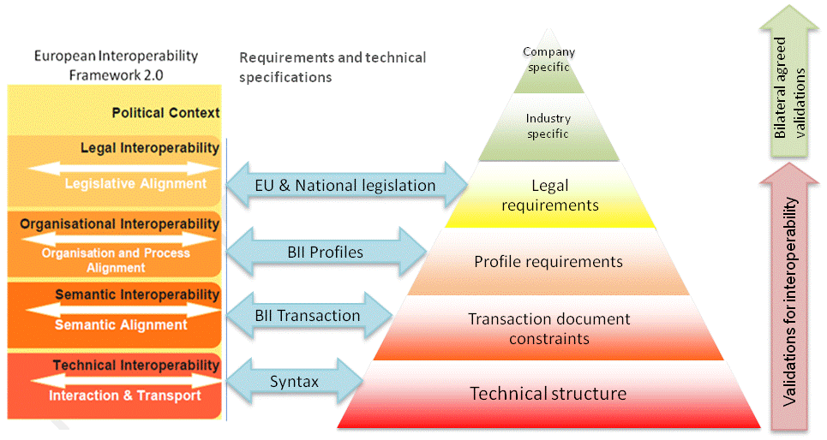
Figure 3 Validation architecture for PEPPOL BIS

Where the technical validation artefacts provide the technical interoperability level, the semantic interoperability is provided by the CEN BII syntax neutral basic document constraints; the organizational interoperability can be validated using the profile requirements and finally, the legal interoperability is validated using legal requirement artefacts.
Different artefacts have been created for the validation of an XML instance in these different layers. The validation of a document instance is applied bottom-up in the pyramid, so the order of validation is:
BII and PEPPOL BIS conformance
The first three levels (technical, transaction and profile) are the basis for interoperability and define the conformance to the BII profile specifications. Every document exchanged must be valid according to these three levels of validation, and everyone in the exchange community must be able to process all received elements in a valid instance.
- Validate that the technical structure of the document is correct.
- Validate the basic common rules for the document to ensure the semantics of the instance are valid
- Validate the process rules as the document instance is used within an specific profile
Processing a document instance does not mean being required to process it automatically. The information in a received instance can be partially processed electronically and partially viewed manually e.g. by use of style sheets. The validation levels in the profile conformance are:
National and EU legal compliance
A document e.g. pre-award eCatalogue must be legally compliant according to the legal environment in which the issuing party operates. In PEPPOL these legal requirements originate from two main sources, EU directives and national laws:
- Validate Pan European legal requirements as specified in the EU directives.
- Validate national legal requirements if the xml instance is in the proper context.

Extended business rules
Even if there is a common interoperability framework where there is a common layout and rules for the documents exchanged within a community, there might be particular requirements at industry level or even at company level.
Specific industries can define rules applicable only to its sector. The same applies to a single company: A single entity can define rules to allow document instances automatically being imported into their IT system.
This completes the validation pyramid with the three upper levels, where the first one comprehends the rule sets to comply with legal rules in different countries while the remaining levels require a bilateral agreement to be used between two trading partners.
- Validate industry-specific requirements. This kind of requirements applies to industries and should be agreed between parties using bilateral agreements. Specifications for this level are not part of PEPPOL.
- Validate entity -specific requirements. This kind of requirements applies to each bilateral exchange between companies and should be agreed between parties by using bilateral agreements. Specifications for this level are not part of PEPPOL.

The purpose of PEPPOL is to create at least one validation artefact for each validation layer, so users get technical material to ensure their implementations are conforming to the standards.
For details on the requirements and solutions for validation see PEPPOL BIS.

Test environment and organisational test preparation

Test planning and controlling
Follow the guidelines in [CTPATF] and align the planning with the overall project plan, possibly by executing a series of workshops in order to verify that the all entities of your solution are covered by the test plan. It is also important to identify and include indirectly related systems into the test plan.
Define the test context, i.e., which profile you want to test and who is responsible for what parts. Design a draft of the test plan.

Test preparation
- Kick-off workshop for the test team
- Setup the test environment and infrastructure
- Create a test plan
- Define test data and test scripts

Test case design
PEPPOL uses the Test Management Tool on [PHLOC] to provide tools, documents, documents, and test cases. A standardized test case template makes sure that the relevant information will be contained in all test cases and will make the test cases reusable.
- Review the test cases on the Test Bed
  - Navigate to the appropriate folder on [PHLOC] and review the test cases that are marked as mandatory, i.e., have the priority “high”
  - The test cases describe the steps to conduct the test execution including preconditions to verify the required condition.
- Recommended: Create new test cases and upload them on the Test Bed
Every PEPPOL pilot should submit example documents as valid test cases and invalid cases (non-valid constellations), with known errors the testers are expected to find. This is to ensure that not only functional transactions but also all validation rules and error handling are working correctly.
The standardized test case template makes sure, that the relevant information will be contained in all test cases and makes test cases reusable (for different test phases, levels).

Test execution and documentation

Standalone Document Validation Testing
According to chapter Error: Reference source not found conformance is achieved when the participant is able to create documents according to one role in a PEPPOL BIS and when the documents conform to the appropriate BIS specifications and business rules.
Most CAs will only create artefacts of certain BIS specifications. Thus, great care must be taken on the creation of differing test cases.
The steps to run the tests are as follows:
- Log on to the [PHLOC] Test Management Tool: http://peppol.phloc.com/config
- Navigate to the test category “Pre Award”
- Review the test cases in “Mandatory Document Validation Testing” (Figure 4)
- Create appropriate test cases according to your role in a PEPPOL BIS
- Create artefacts according to your test cases
- Validate the artefacts using the validation tool on [PHLOC]
- Execute your test cases on [PHLOC] and set the result (Figure 5)
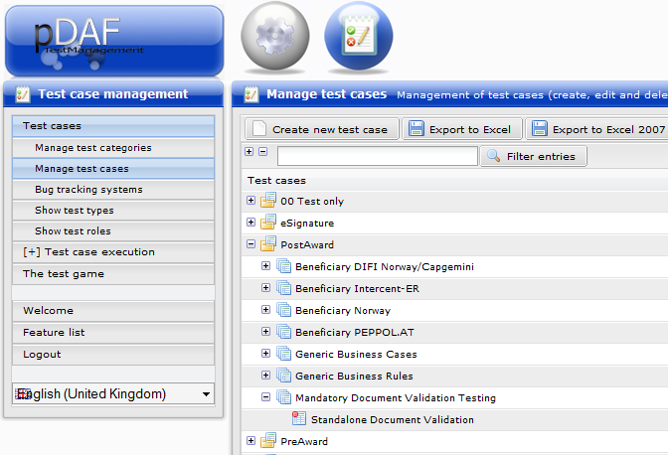
Figure 4: Test Case for Document Validation
In order to achieve conformance you should test 10-20 artefacts depending on the document type, transaction, and national rules.

SUT-Interactive Conformance Testing
According to chapter Error: Reference source not found conformance is achieved when the Solution is able to receive documents according to one role in a PEPPOL BIS.
The steps to run the tests are as follows:
- Log on to the [PHLOC] Test Management Tool: http://peppol.phloc.com/config
- Navigate to the test category “Pre Award”
- Review the test cases in “Generic Business Rules” and “Mandatory SUT-Interactive Conformance Testing”
- Review the test cases that apply to your Solution
- Retrieve the XML attachments from the test cases marked as “high priority”
- Use the artefacts from the test cases in your SUT and note the results
- Execute the test cases on [PHLOC] and set the result status accordingly (Figure 5).
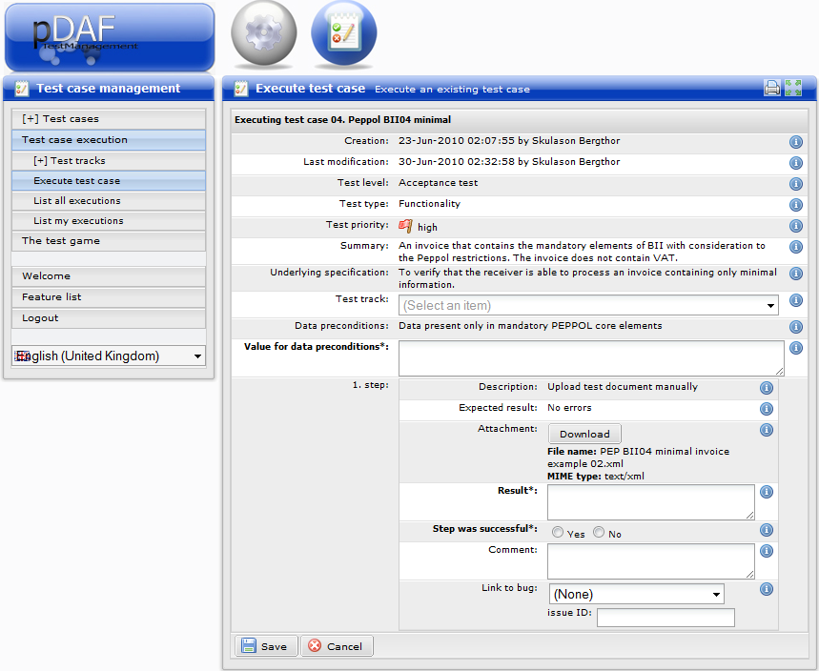
Figure 5: Execute a Test Case

Defect Management
It is important to track the status of tests during the execution of test runs. The status of tests can also be documented and tracked on [PHLOC] if necessary. There is a list of test cases available that were executed by a user (Figure 6). This list can be sorted by the success status.

Test cases will also be organized in Test tracks that make it easy to get an overview about test executions that were successful or failed (Figure 7).
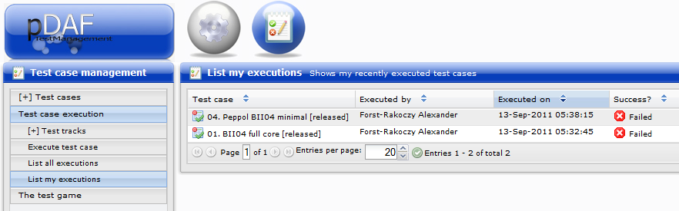
Figure 6: List my executions
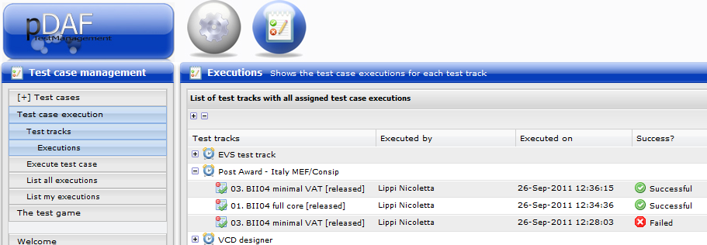
Figure 7: Test track executions

Reporting
Process of testing and testing results has to be documented as part of the process for reporting and for verification purposes. PEPPOL will report to project beneficiaries and the EU on results of interoperability testing and hindrances to cross border trade identified. To support these objectives the participants have developed templates and reporting tools [CTPATF, PHLOC].
Participants are encouraged to input test cases by using provided templates and tools to report the outcome of the execution – you can save a lot of work!
A report of the executed test cases and results can be automatically generated by the PEPPOL Test Management and Development tool [PHLOC].

Test Tools
Test tools are provided to establish and support a shared testing process within PEPPOL community. The following tools are provided:
- Test Management Tool (web interface) provides the support for testers, access to information and documentation within PEPPOL:
- Test cases (test case management)
- Test execution (documentation of results on basis of test cases)
- Shared documents (such us e.g. test guidelines, lessons learned documentation...)
- Access for documenting test results and lessons learned.
- Link with defects on OSOR
- Link to other relevant test material or sites.
- Validation Tool (web interface) supports:
- UBL validation rules (XML schema)
- CEN BII rules (Schematron)
- PEPPOL BIS rules (Schematron)
- (Optional) national invoicing rules as they become available to the team of testers (Schematron).

Document instances, can be handcrafted or created by automated processes.
Test report template:
- Needs to be used to report the outcome of a each test phase (sum of all test executions for a certain test type) by participant

  - Test Management Tool
The PEPPOL team uses Test Management Tool to provide access to other tools, documents and information for tester available on a daily basis, while testing is underway.
Test cases describe the steps to conduct the test execution including preconditions to verify the require condition.
Every PEPPOL implementation should submit example documents as valid test cases (describing what has to happen) and invalid cases (non-valid constellations), with known errors the testers are expected to find. This is to ensure that not only functional transactions but also all validation rules and error handling are working correctly.
A standardized test case template makes sure that the relevant information will be contained in all test cases and makes test cases reusable (for different test phases, levels …).
The Test Management Tool is available as a public version for general information on PEPPOL testing and as test case management tool with restricted access.

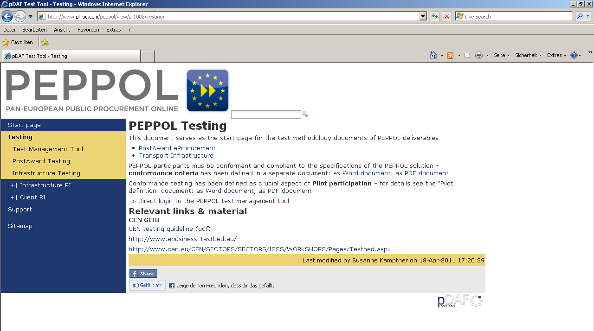
Figure 8: Public Test Management Page

How to use the tool for Test case administration
The PEPPOL test management tool is located at http://www.phloc.com/peppol/config
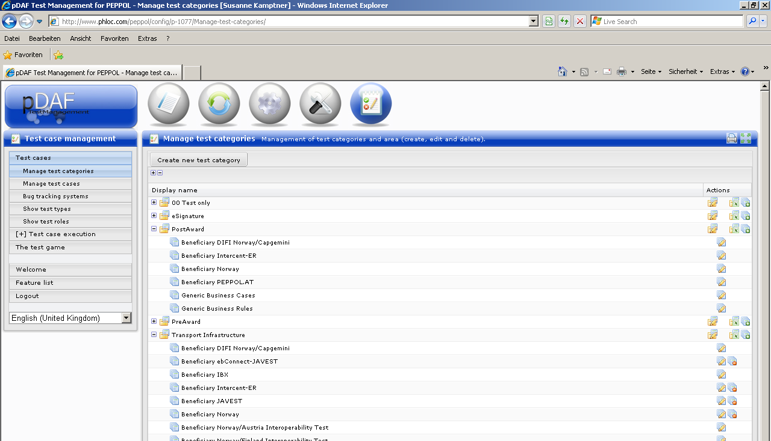
Figure 9. Manage test categories and test areas
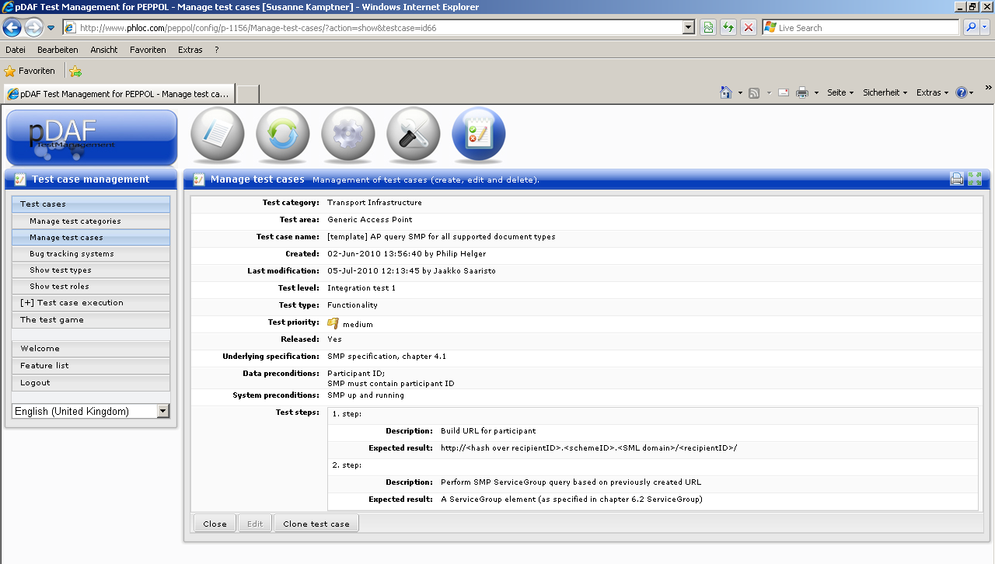
Figure 10: Test case (detail)

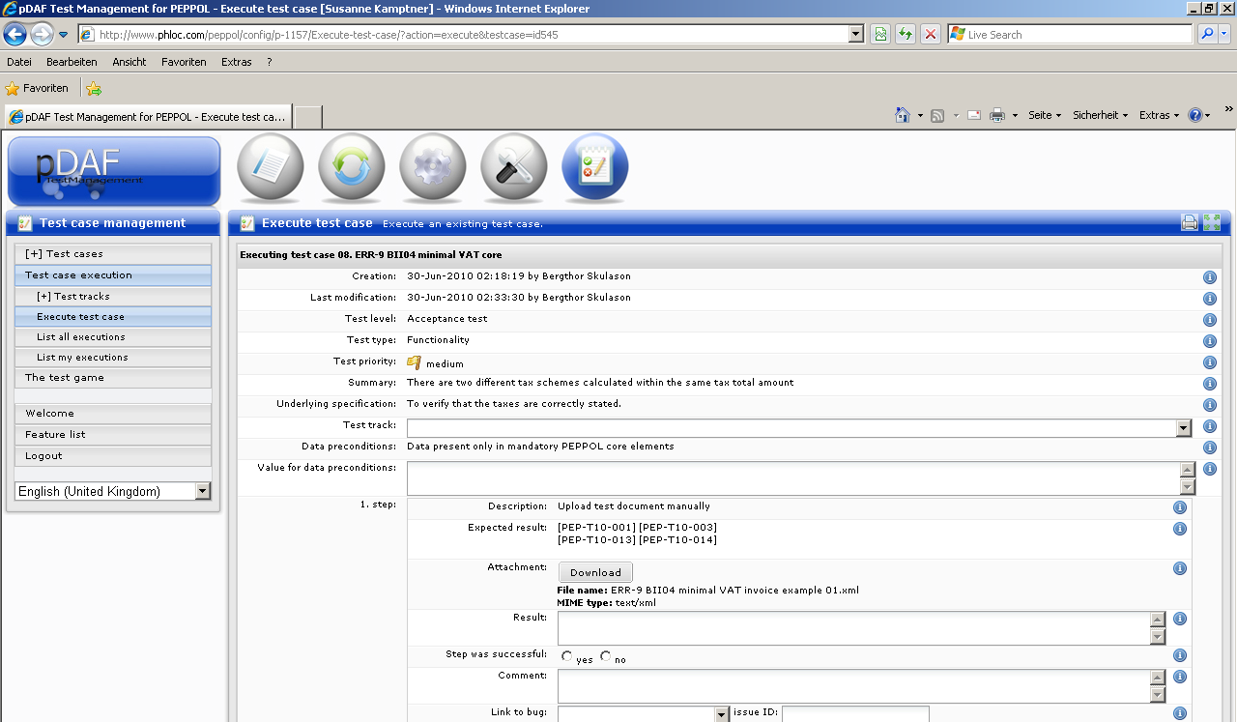
Figure 11: Execute a test case
  - Validation Tool

Schematron files
Technical tools produced in PEPPOL to validate XML eDocuments (Catalogues, Invoice, Order, etc.) instances are based on Schematron. The Schematron validation artefacts are packaged into the Java reference implementation inside the project “validation-peppol-rules”. This project contains the relevant Schematron artefacts to validate PEPPOL UBL documents using the Schematron validation component also provided in the reference implementation. The Schematron files are not available as a separate package as the runtime behaviour of them is partially quite poor because of its extensive amount of rules. Instead a “pre-compiled” XSLT version of the Schematron files is used to perform the actual validation even though the original Schematron files are provided for sanity reasons.
The reference implementation uses Saxon 9.3 as the reference XSLT processor. All Schematron artefacts were validated against this specific processor. Other XLST processors (e.g. the ones build into browsers) may result in different warnings and errors leading to an invalid validation!
For detailed information on how to use the validation project of the reference implementation, please refer to the PEPPOL development support website (www.phloc.com/peppol).

XSLT files
There are several ways of implementing Schematron validators. PEPPOL has used the validator implementation defined by Schematron to create XSLT files that parse and validate XML instances, producing an SVRL output.
SVRL stands for Schematron Validation Report Language and is a reporting language defined within ISO Schematron that produces an XML instance that identifies errors or warnings of an XML document.
This is the reference implementation of Schematron rules, but it could be implemented in many other ways.
XSLT validation files have the same pattern names as the original Schematron files but with the file extension “.xslt”.

How to use validation artefacts
Validation artefacts can be used in different testing environments. They can be used from within XML processing tools or in different environments supporting XSLT or Schematron engines such as web browsers. Please recall that the results produced in this testing environments may differ from the results of the reference implementation, cause by XSLT processor differences.
      - Using XML processing tools
XML processing tools such as Altova® XmlSpy or Oxygen® among others can be used to test XML instances. This kind of tools can process both Schematron and XSLT files.
      - Test an instance using Schematron in Oxygen
Oxygen is a commercial XML IDE that has integrated Schematron support. Perform the following steps to create an SVRL file as the validation result of a Schematron file upon an UBL document.

- Open the XML instance
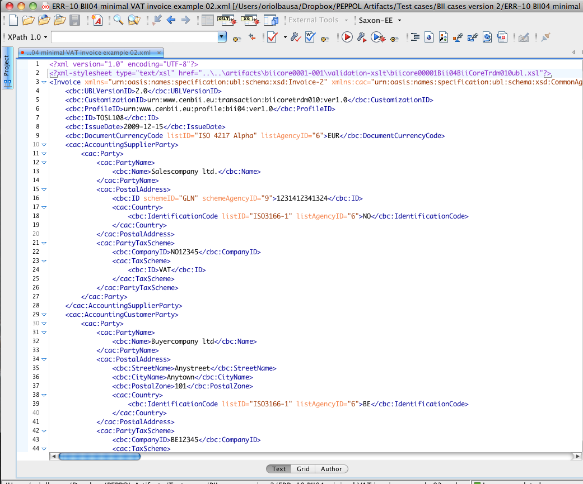

- Select Validate with…
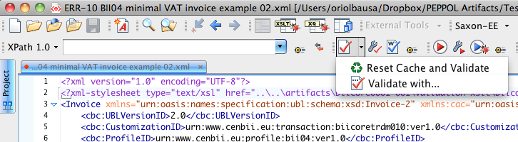

- Select Schematron in the dropdown box
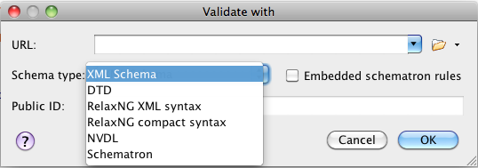

- Select the Schematron file you want to use
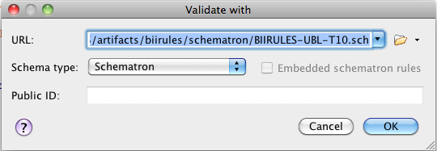

- Select the Phase you want to run (usually there is only one phase)
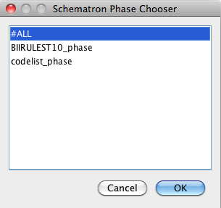

- Get the results
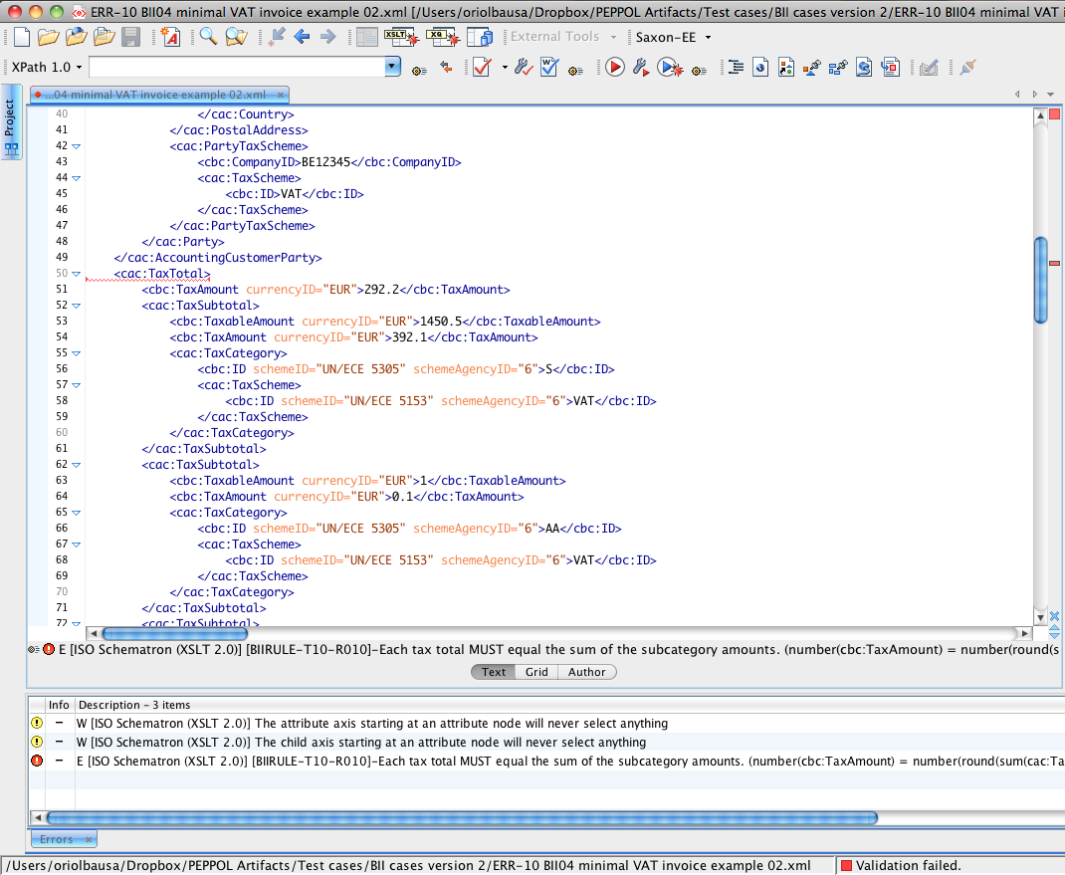

      - Test an instance using XSLT in Oxygen
- Open the XML instance (invoice in the example)

- Open the XSLT validation file

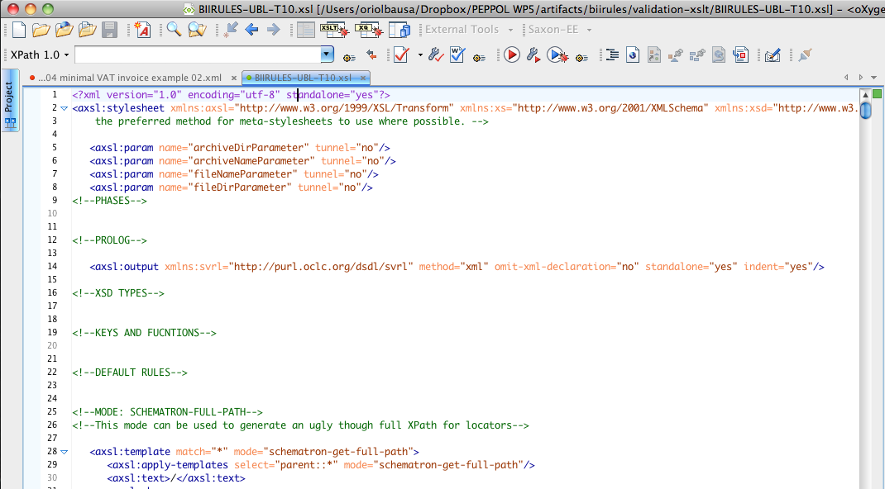

- Go to XSLT mode pressing the XSLT button 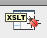

- Run the XSLT and get the SVRL instance
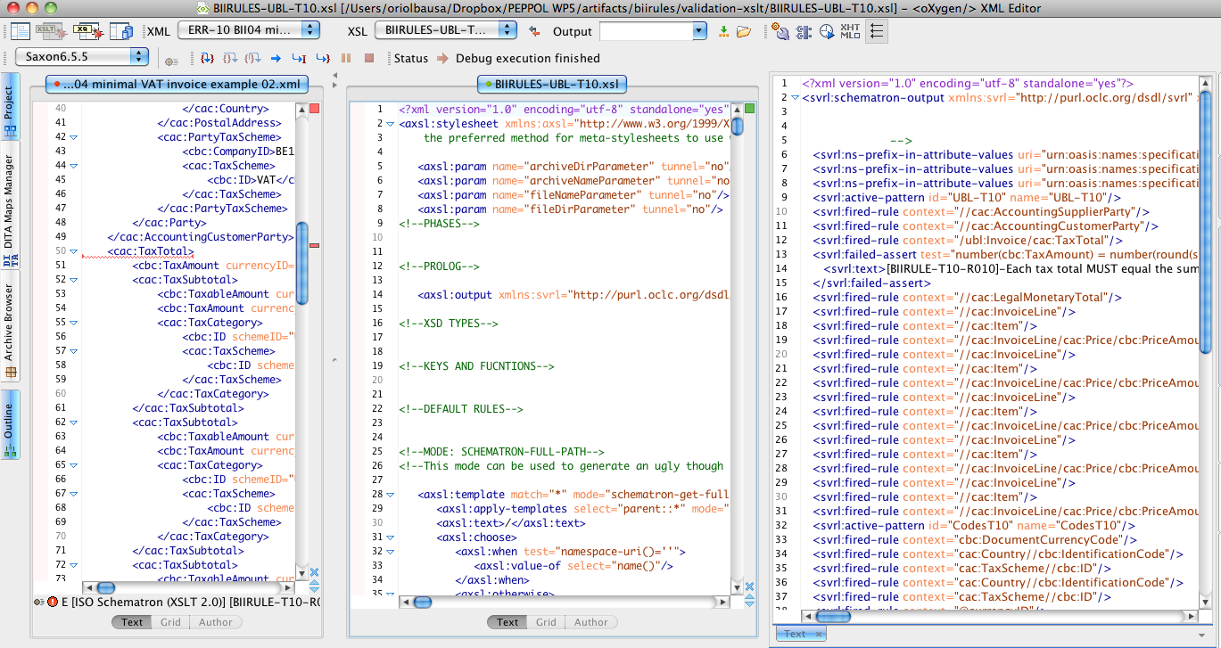
Figure 12 UBL, XSLT and SVRL inside oXygen
      - Using a web browser
Web Browsers also include an XSLT engine. A web page can be set up to validate document instances using the built-in XSLT engine. Please recall that the validation results in a browser may differ from the validation results of the reference implementation because of differences in the XSLT processor.
      - Test an instance using a web validation tool
- Open web validation tool page
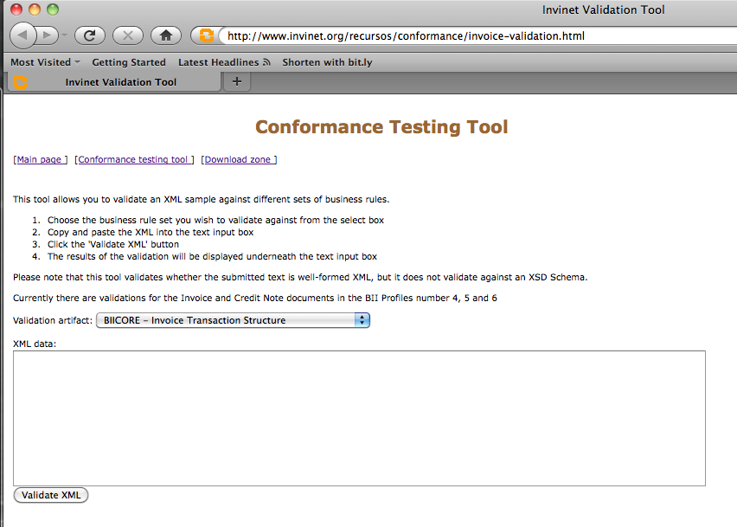

- Copy & paste an XML invoice instance in the text area
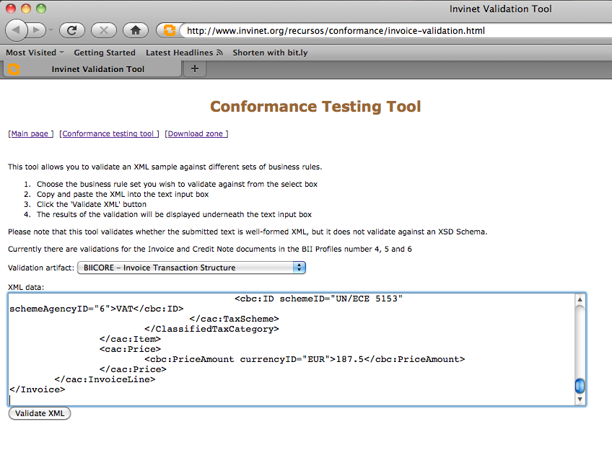

- Select the validation artefact to run
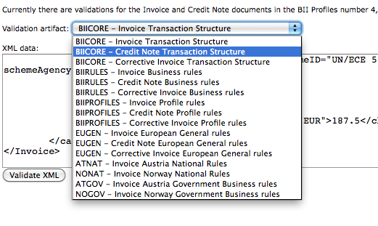

- Press validate button
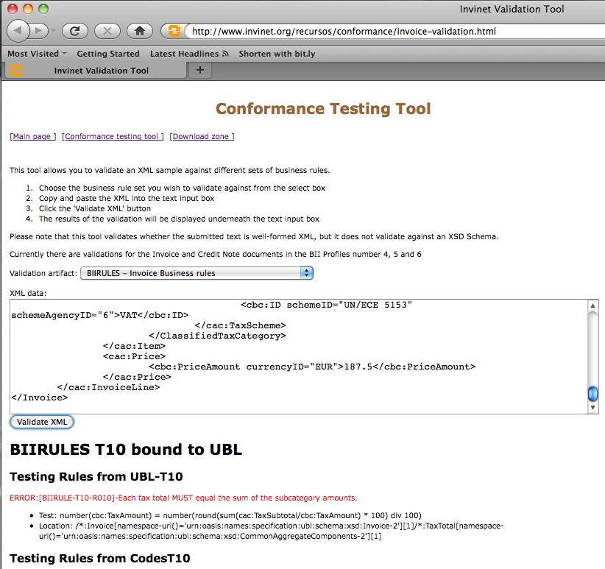

Appendix – Abbreviations
Abbreviation | Meaning
AP | Access Point
ASAP | As soon as possible
BIS | Business Interoperability Specification  (former: PEPPOL profile)
CA | Contracting authority (e.g. buyer)
EO | Economic operator
EUGEN | European Union Generic
OSOR | Open Source Observatory and Repository
OSS | Open Source Software
PEPPOL | Pan-European Public Procurement On-Line
SML | Service Metadata Locator
SMP | Service Metadata Publisher
SVN | Subversion
WPM | Work Package Manager
SUT | System Under Test
CEN | Comité Européen de Normalisation  European Committee for Standardization
BII | Business Interoperability Interface
CENBII | CEN/ISSS Business Interoperability Interfaces  for Public procurement  in Europe
EIF | European Interoperability Framewokr 2.0

English: Austrian Federal Computing Centre
English: Federal Procurement Agency
EEA is the European Economic Area. Current members are Iceland, Liechtenstein and Norway.
The Solution is the system or software that sends/receives document instances.
Taken from CEN ISSS WS/BII Test Guidelines, Version 1.0
http://europa.eu/index_en.htm
http://www.phloc.com/peppol/
http://www.schematron.com
Saxon is Open Source and is available both for Java and for .NET
http://www.schematron.com/implementation.html
http://www.oxygenxml.com/

